Playlist for System design SDE-III

🟢 PHASE 0 — Pre-Requisites (DO NOT SKIP)
🎯 Goal: Speak System Design language confidently
Topics
- OOPS principles (SOLID, DRY, KISS)
- REST vs gRPC
- HTTP lifecycle
- Basic networking (DNS, TCP vs UDP)
- CAP theorem
- ACID vs BASE

🟣 PHASE 1 — Low Level Design (LLD) — FOUNDATION
🎯 Goal: Clean code + extensible design
1️⃣ OOPS Deep Dive
- Abstraction vs Encapsulation
- Inheritance vs Composition
- Interface vs Abstract class
🎥 Playlist videos:
- “OOPS for System Design (Real Examples)”
- “Why Composition > Inheritance in Real Systems”
2️⃣ SOLID Principles (VERY IMPORTANT)
- S — Single Responsibility
- O — Open/Closed
- L — Liskov Substitution
- I — Interface Segregation
- D — Dependency Inversion
🎥 Videos:
- “SOLID Explained with Java Backend Examples”
- “How SOLID Improves Scalability”
3️⃣ Design Patterns (Interview MUST)
Pattern | Use Case
Singleton | DB connection
Factory | Payment gateway
Strategy | Pricing logic
Observer | Notification
Decorator | Feature toggle
🎥 Videos:
- “Top 10 Design Patterns Every SDE-III Must Know”
- “Design Patterns in Real Microservices”

4️⃣ LLD Case Studies (Code-level)
🎯 You must implement
- Parking Lot
- Elevator System
- BookMyShow (LLD)
- Rate Limiter (Token Bucket)
- Cache (LRU, LFU)
🎥 Videos:
- “LLD: Parking Lot (Java)”
- “Design LRU Cache from Scratch”
📌 Deliverable
- Class diagram
- Interfaces
- Sample code
- Extension points

🔵 PHASE 2 — Core HLD Concepts (NON-NEGOTIABLE)
🎯 Goal: Think in scale & traffic
5️⃣ Architecture Fundamentals
- Monolith → Microservices
- Sync vs Async
- API Gateway
- Event-Driven systems
🎥 Videos:
- “How Monoliths Break at Scale”
- “When to Use Kafka vs REST”
6️⃣ Scalability
- Load Balancer
- Horizontal vs Vertical Scaling
- Auto-scaling
- Caching (Redis)
🎥 Videos:
- “Design for 10M Users”
- “Cache Strategies Explained”
7️⃣ Reliability & Resilience
- Idempotency
- Retry + Backoff
- Circuit Breaker
- Graceful Degradation
🎥 Videos:
- “How Netflix Handles Failures”
- “Designing Fault-Tolerant Systems”

8️⃣ Data Layer
- SQL vs NoSQL
- Indexing
- Sharding & Partitioning
- Replication
🎥 Videos:
- “Choosing Database for Scale”
- “How Sharding Actually Works”

🟠 PHASE 3 — Advanced HLD (SDE-III Level)
🎯 Goal: Ownership & correctness
9️⃣ Distributed Systems
- CAP theorem in real systems
- Strong vs Eventual consistency
- Exactly-once processing
- Saga pattern
🎥 Videos:
- “Why Distributed Systems Are Hard”
- “How Payments Stay Correct”
🔟 Messaging & Streaming
- Kafka internals
- Partitions & consumer groups
- Ordering & replay
- Dead Letter Queue
🎥 Videos:
- “Kafka Deep Dive for Backend Engineers”
- “Design Event-Driven Systems”
1️⃣1️⃣ Security
- OAuth2, JWT
- Rate limiting
- API authentication
- Secrets management
🎥 Videos:
- “Secure APIs at Scale”
- “System Design Security Checklist”

🔴 PHASE 4 — System Design Case Studies (INTERVIEW CORE)
🎯 Goal: Crack actual interviews
MUST-DESIGN Systems
System
Payment Gateway
Wallet / Ledger
Notification Service
Rate Limiter
URL Shortener
Chat System
Feed System
Search Autocomplete

🎥 Videos:
- “Design Payment System (End-to-End)”
- “Wallet System with Strong Consistency”
📌 Each video must cover:
- Requirements
- API design
- DB schema
- Scaling
- Failure handling
- Trade-offs

🎥 SYSTEM DESIGN YOUTUBE PLAYLIST (DAY-WISE)

🔰 PHASE 0 — FOUNDATION (Day 1–7)
Goal: Think & speak system design language
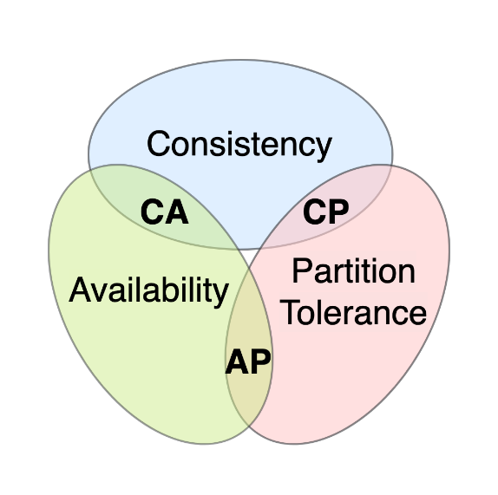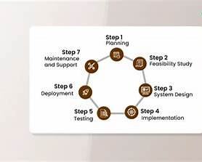
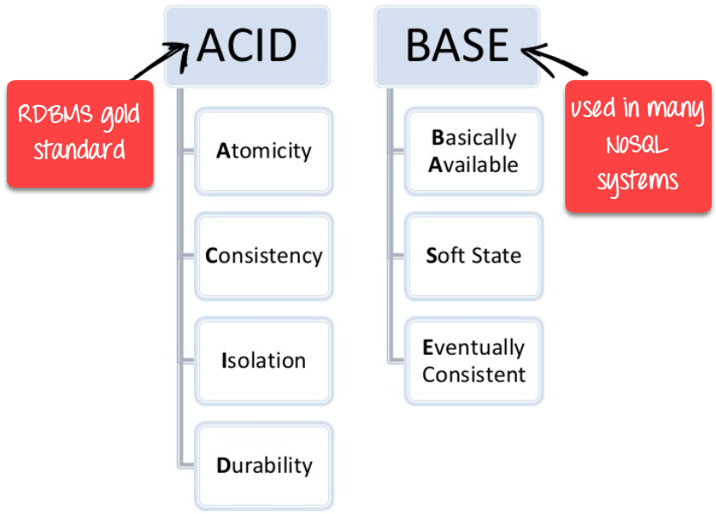

Day 1
▶ What is System Design?
▶ LLD vs HLD (Expectations for SDE-III)
Day 2
▶ OOPS Refresher for Backend Engineers
▶ Abstraction vs Encapsulation (Real Examples)
Day 3
▶ Inheritance vs Composition
▶ Interface vs Abstract Class (When to use what)
Day 4
▶ SOLID Principles Overview
▶ Why SOLID matters in large systems
Day 5
▶ REST API Design Basics
▶ HTTP Lifecycle + Status Codes
Day 6
▶ Networking Basics: DNS, TCP vs UDP
▶ Latency vs Throughput
Day 7
▶ CAP Theorem
▶ ACID vs BASE (Interview Mapping)

🧱 PHASE 1 — LOW LEVEL DESIGN (Day 8–30)
Goal: Clean, extensible, production-ready code

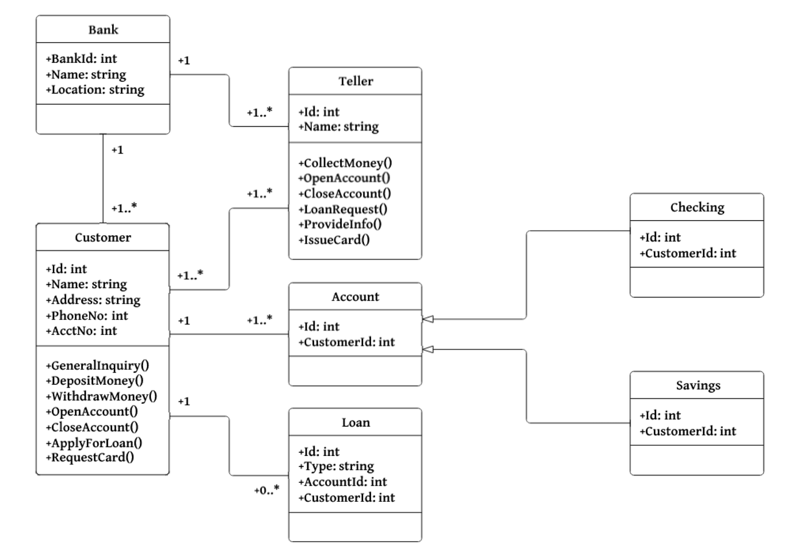

🔹 OOPS + SOLID (Day 8–12)
Day 8 – Single Responsibility Principle
Day 9 – Open/Closed + Liskov
Day 10 – Interface Segregation + Dependency Inversion
Day 11 – How SOLID improves scalability
Day 12 – Refactoring bad code using SOLID

🔹 Design Patterns (Day 13–18)
Day 13 – Singleton (DB, Configs)
Day 14 – Factory & Abstract Factory
Day 15 – Strategy Pattern (Pricing / Offers)
Day 16 – Observer Pattern (Notifications)
Day 17 – Decorator Pattern (Feature flags)
Day 18 – Pattern selection guide (Interview Q&A)

🔹 LLD Case Studies (Day 19–30)
Day 19 – Parking Lot (Requirements + Classes)
Day 20 – Parking Lot (Code + Extensions)
Day 21 – Elevator System (Concurrency)
Day 22 – Elevator Optimizations
Day 23 – LRU Cache Design
Day 24 – LFU Cache Design
Day 25 – Rate Limiter (Token Bucket)
Day 26 – Rate Limiter (Sliding Window)
Day 27 – BookMyShow LLD
Day 28 – BookMyShow Scaling Considerations
Day 29 – LLD Interview Mock
Day 30 – LLD Revision + Cheatsheet

🏗️ PHASE 2 — HLD CORE (Day 31–55)
Goal: Design scalable & reliable systems
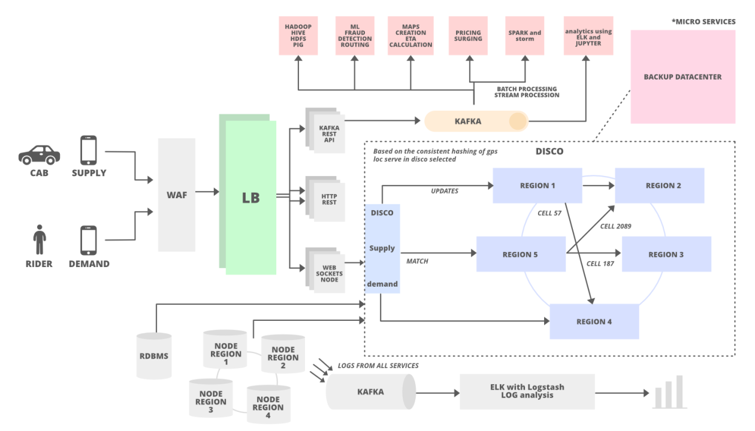
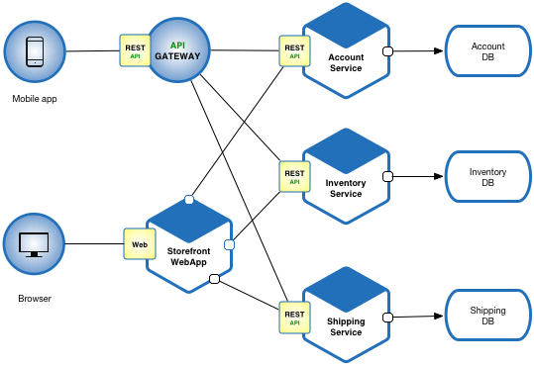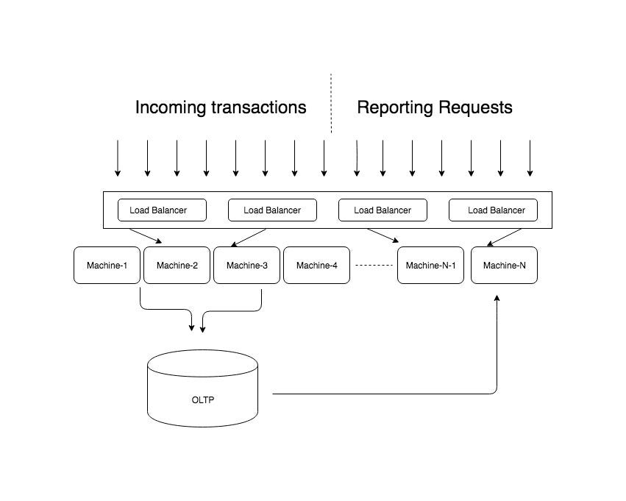

🔹 Architecture (Day 31–36)
Day 31 – Monolith vs Microservices
Day 32 – Service Decomposition Strategies
Day 33 – Sync vs Async Communication
Day 34 – API Gateway Design
Day 35 – Event-Driven Architecture
Day 36 – Choosing architecture in interviews

🔹 Scalability (Day 37–43)
Day 37 – Load Balancers
Day 38 – Horizontal vs Vertical Scaling
Day 39 – Auto-Scaling Strategies
Day 40 – Caching Basics (Redis)
Day 41 – Cache Eviction Strategies
Day 42 – CDN & Geo-distribution
Day 43 – Scaling checklist (10M users)

🔹 Reliability (Day 44–49)
Day 44 – Idempotency
Day 45 – Retry + Exponential Backoff
Day 46 – Circuit Breaker Pattern
Day 47 – Graceful Degradation
Day 48 – Designing for Failures
Day 49 – Reliability Interview Questions

🔹 Data Layer (Day 50–55)
Day 50 – SQL vs NoSQL
Day 51 – Indexing Deep Dive
Day 52 – Sharding & Partitioning
Day 53 – Replication
Day 54 – Data Modeling for Scale
Day 55 – Database Selection Matrix

🌐 PHASE 3 — ADVANCED DISTRIBUTED SYSTEMS (Day 56–70)
Goal: SDE-III ownership & correctness
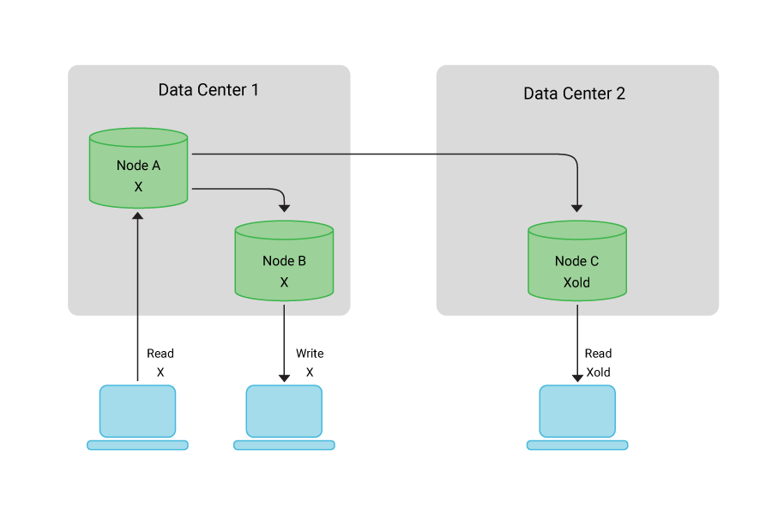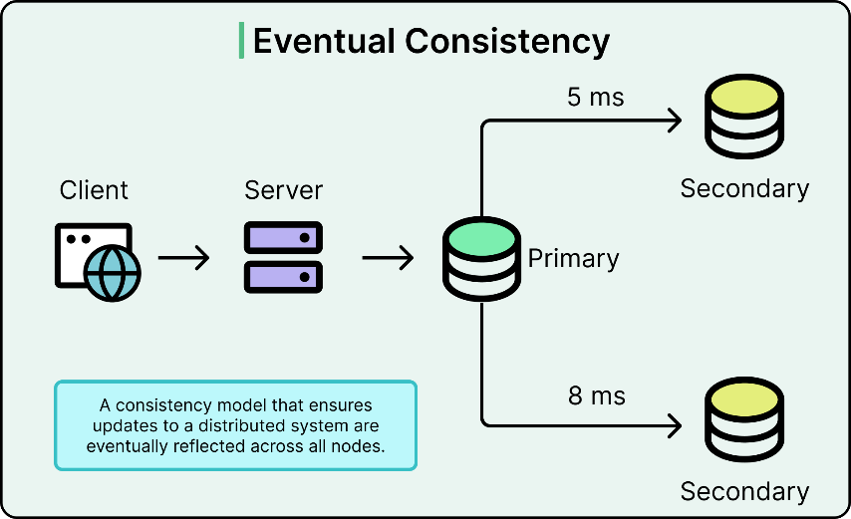
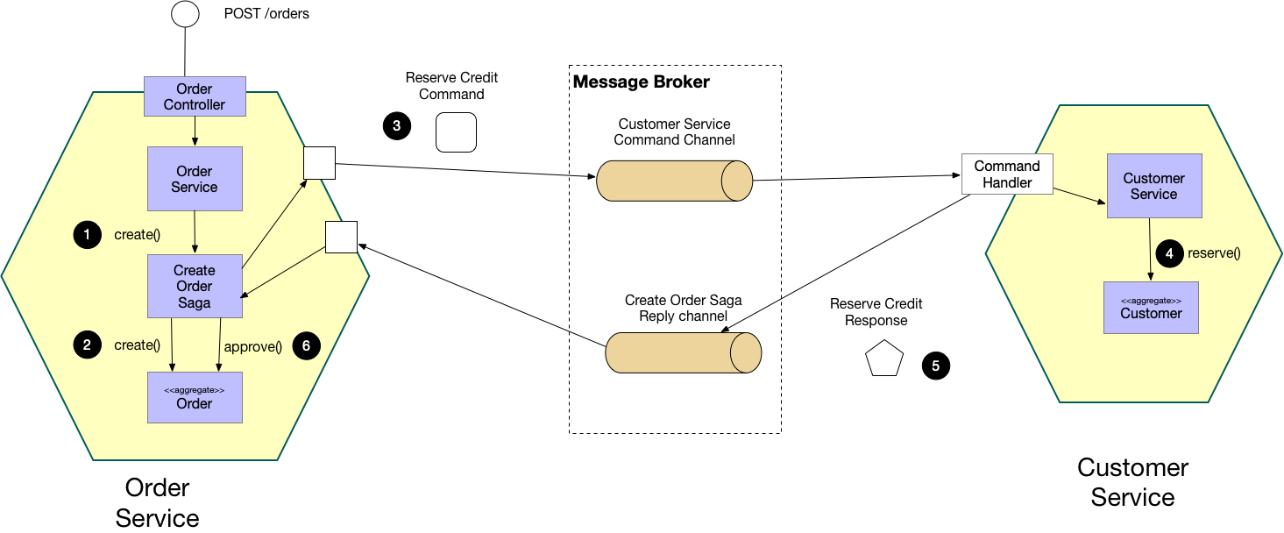

Day 56 – Distributed Systems Basics
Day 57 – CAP Theorem (Real Trade-offs)
Day 58 – Strong vs Eventual Consistency
Day 59 – Exactly-Once Processing
Day 60 – Saga Pattern
Day 61 – Kafka Architecture
Day 62 – Partitions & Consumer Groups
Day 63 – Ordering & Replay
Day 64 – Dead Letter Queue
Day 65 – OAuth2 & JWT
Day 66 – API Security
Day 67 – Rate Limiting at Scale
Day 68 – Secrets & Key Management
Day 69 – Security Interview Q&A
Day 70 – Advanced Revision

🔥 PHASE 4 — SYSTEM DESIGN CASE STUDIES (Day 71–85)
Goal: Crack real interviews

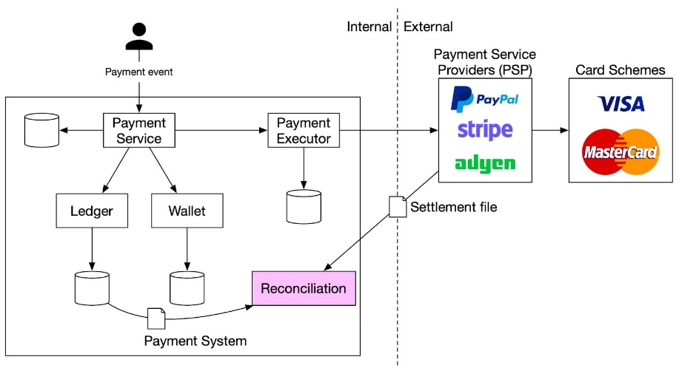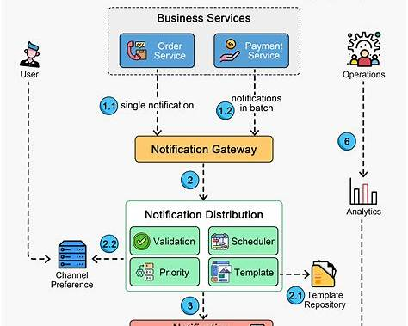

Day 71 – URL Shortener
Day 72 – Rate Limiter (HLD)
Day 73 – Notification System
Day 74 – Chat System
Day 75 – Feed System
Day 76 – Payment Gateway
Day 77 – Wallet / Ledger System
Day 78 – Exactly-Once Payments
Day 79 – Search Autocomplete
Day 80 – Analytics System
Day 81–85 – Full Mock Designs (45-min each)

🎯 PHASE 5 — MOCK INTERVIEWS (Day 86–90)
Goal: Interview confidence
Day 86 – How to approach System Design Interview
Day 87 – Thinking aloud strategy
Day 88 – Common mistakes
Day 89 – SDE-III Mock Interview
Day 90 – Final Revision & Checklist

